Country
 | Student 1 | Student 2 | Student 3
Name
Code
Signature

Experiment I. Determination of the Densities of Fruit Juices
Questions  (Points) |  | Data and Answers
I-1  (6.0) | I-1-1  (1.25) |  |  | d₀ | d₁ |  | d₂ | d₃ |  | d₄
 |  | Masses (g)
 |  | Lengths of spring (cm)
I-1-2
(2.5)
 | I-1-3  (1.25) | Slope | cm/g |  |  | Intercept |  |  | cm

 | Student 1 | Student 2 | Student 3
Name
Code

Experiment I. Determination of the Densities of Fruit Juices (Cont’d)
I-1  (6.0) | I-1-4  (1.0) | (Show your working)
 |  | Spring Constant | N/m
I-2  (6.0) | I-2-1 (2.0) | Immersed weights | 50g + 50g | 50g + 50g + 50g
Volume of water
without weights in it (cm³)
 |  | Volume read from scale after immersing weights (cm³)
Volume difference (cm³)
(= Volume of liquid displaced)

 | Student 1 | Student 2 | Student 3
Name
Code

Experiment I. Determination of the Densities of Fruit Juices (Cont’d)
Questions  (Points) |  | Data and Answers
I-2  (6.0) | I-2-2  (2.0) | Juice | Apple |  | Mandarin
 |  | Lengths of spring with the weights outside juice (cm)
 |  | Immersed weights | 50g + 50g | 50g + 50g + 50g | 50g + 50g | 50g + 50g + 50g
 |  | Length of spring with the weights after immersing (cm)
 |  | Length difference (cm)
 | I-2-3  (2.0) | Buoyant force (N)
I-3  (2.0) |  | Density (g/cm³)
 |  | Average density (g/cm³)

------------------------------------ DO NOT WRITE BELOW ------------------------------------
Total points for experiment I

 | Student 1 | Student 2 | Student 3
Name
Code

Experiment II. Determination of the Citric Acid Contents in Fruit Juices
Questions  (Points) | Data and Answers
II-1  (7.0) | Show your calculation of the average titer (for both juices)
 |  | Juices
 |  | Mandarin |  |  |  | Apple
 | Trials | 1 | 2 | 3 | 4 | 5 | 6 | 7 | 8
 | Initial Readings (in )
 | Final Readings (in )
 | Volumes of NaOH solution consumed for titration
 |  | Average volume |  |  |  | Average volume

 | Student 1 | Student 2 | Student 3
Name
Code

Experiment II. Determination of the Citric Acid Contents in Fruit Juices (Cont’d)
Questions  (Points) | Data and Answers
II-2  (2.0) | (Show your working)
 | Moles of NaOH | Mandarin |  | Apple

 | Student 1 | Student 2 | Student 3
Name
Code

Experiment II. Determination of the Citric Acid Contents in Fruit Juices (Cont’d)
Questions  (Points) | Data and Answers
II-3  (2.0) | (Show your working)
 | Moles of citric acid | Mandarin |  | Apple
 | Masses of citric acid | Mandarin |  | Apple

 | Student 1 | Student 2 | Student 3
Name
Code

Experiment II. Determination of the Citric Acid Contents in Fruit Juices (Cont’d)
Questions  (Points) | Data and Answers
II-4  (2.0) | (Show your working)
 | Percent concentration of citric acid | Mandarin | % | Apple | %
------------------------------------ DO NOT WRITE BELOW ------------------------------------
Total points for experiment II

 | Student 1 | Student 2 | Student 3
Name
Code

Experiment III. Anatomy and classification of fruits and seeds
Question  (Points) | Data and Answers
III-1  (1.0) | Location of the structure(s) originated from A
III-2  (2.5) | Location of the tissues originated from A, B, C and D

 | Student 1 | Student 2 | Student 3
Name
Code

Experiment III. Anatomy and classification of fruits and seeds (Cont’d)
Question  (Points) | Data and Answers
III-3-1  (2.0) |  |  | fruits
 | Fruits for ① and ②
III-3-2  (2.0) | Classification schemes for ‘c’ and ‘d’ |  | characters
 |  |  | c |  | d
III-3-3  (4.0) | Fruit Classification A Acorn B Apple C Bean pod D Lychee E Lemon F Persi-mmon G Rice H Straw-berry  Single seed fruit  Many seeded fruit  Aggregate fruit  Multiple fruit  True fruit  Accessory fruit  Fleshy fruit  Dry fruit
 |  | Student 1 |  | Student 2 |  | Student 3
Name
Code

III-3-4  (1.5) | 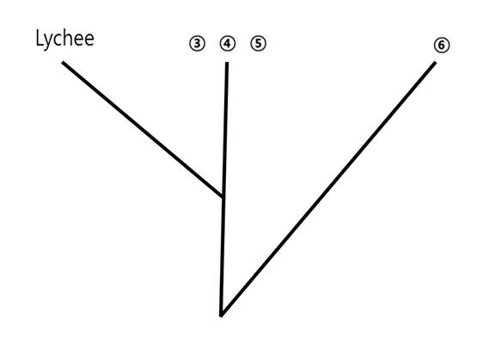
 | Number | Alphabet in Box 1
 | ③
 | ④
 | ⑤
 | ⑥
------------------------------------ DO NOT WRITE BELOW ------------------------------------
Total points for experiment III

